24th International Conference on Material Forming (ESAFORM 2021)
Title of your paper with Capitalize first letter
First Authorª, Second Author^{b}, Third Author^{a,b,*}
ªFirst affiliation, Country
^{b}Second affiliation, Country

* Corresponding author: name and first name. E-mail address: author@universitiy.xxx

Abstract. (Normal 9 point font; max. 300 words) Lorem ipsum dolor sit amet, consetetur sadipscing elitr, sed diam nonumy eirmod tempor invidunt ut labore et dolore magna aliquyam erat, sed diam voluptua. At vero eos et accusam et justo duo dolores et ea rebum. Stet clita kasd gubergren, no sea takimata sanctus est Lorem ipsum dolor sit amet.
Keywords: Enter here your keywords; Separate the keywords with semicolons;
- Introduction (10 point bold font)
Scientific papers will be between 2500 and 3000 words (outside title, authors, affiliations, references). Industrial communications will have a reduced length between 1000 and 1500 words.
The format is normal 10 point font. Use always “Times New Roman” font. Indicate references have to be used in the text [1]. References are listed at the end of the paper [2,3]. Please check that every reference appears in the text and in the list of references at the end of the paper.
Lorem ipsum dolor sit amet, consetetur sadipscing elitr, sed diam nonumy eirmod tempor invidunt ut labore et dolore magna aliquyam erat, sed diam voluptua. At vero eos et accusam et justo duo dolores et ea rebum. Stet clita kasd gubergren, no sea takimata sanctus est Lorem ipsum dolor sit amet. Lorem ipsum dolor sit amet, consetetur sadipscing elitr, sed diam nonumy eirmod tempor invidunt ut labore et dolore magna aliquyam erat, sed diam voluptua. At vero eos et accusam et justo duo dolores et ea rebum. Stet clita kasd gubergren, no sea takimata sanctus est Lorem ipsum dolor sit amet. Lorem ipsum dolor sit amet, consetetur sadipscing elitr, sed diam nonumy eirmod tempor invidunt ut labore et dolore. Stet clita kasd gubergren, no sea takimata sanctus est Lorem ipsum dolor sit amet. Lorem ipsum dolor sit amet, consetetur sadipscing elitr, sed diam nonumy eirmod tempor invidunt ut labore et dolore.
- Tables and Figures
  - Tables (10 point italic font)
Every table must have a caption, which is above the table and is centric. Every table must be numbered with Arabic numbers. The column headings should be separated from the body of the table with a horizontal line. The format is normal 8 point font. Lorem ipsum dolor sit amet, consetetur sadipscing elitr, sed diam nonumy eirmod tempor invidunt ut labore et dolore magna aliquyam erat, sed diam voluptua.
Table 1. Title of the table.
Area | Variant A | Variant B
AM | 10 | 20
Joint | 50 | 40
Substrate | 30 | 06
  - Figures
All diagrams, schemas, graphs, photographs, etc. must be referend in the text as figures. Every figure must have a caption, which is below the figure and is centric. Every figure must be numbered with Arabic numbers. The caption and letters in the figures must have normal 8 point font. If possible figures should be placed as close as possible to the first reference. Two or more figures can be places next to each other, if they fit next to each other like in Fig. 1.
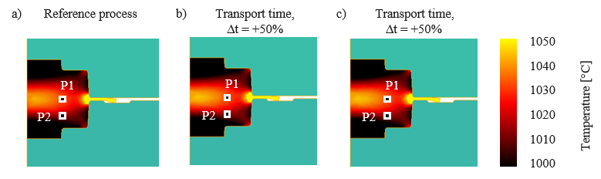
Fig. 1. Simulation results of the last forming step for a deviation of the furnace temperature.
(a) Showing the reference process at 1000°C, (b) the reduced furnace temperature at 990°C and (c) the retrieved temperature level by adjusting the impact energy
- Equations
Use Mathtype for formulas and equations and number them with Arabic numbers in parentheses on the right side like in the example (1).
$W=W_{pl}+W_{el}=\int_{0}^{s}{F∙ds}+\frac{1}{2}F_{max}f_{z}$ (1)
Acknowledgements
Lorem ipsum dolor sit amet, consetetur sadipscing elitr, sed diam nonumy eirmod tempor invidunt ut labore et dolore magna aliquyam erat, sed diam voluptua. At vero eos et accusam et justo duo dolores et ea rebum. Stet clita kasd gubergren, no sea takimata sanctus est Lorem ipsum dolor sit amet.
References
[1] Graf, M. Pradjadhiana, K. Hälsig, A. Manurung, Y. Awiszus, B. Numerical simulation of metallic wire arc additive manufacturing (WAAM). AIP Conference Proceedings, 2020, 140010. DOI 10.1063/1.5035002.
[2] Graser, M. Wiesenmayer, S. Müller, M. Merklein, M. Application of Tailor Heat Treated Blanks Technology in a Joining by Forming Process. Journal of Material Processing Technology, 2019, 264, S. 259-272
[3] World Aluminium. Primary Aluminium Smelting Energy Intensity, 2019, http://www.world-aluminium.org/statistics/primary-aluminium-smelting-energy-intensity/, 11.11.2019.

